Lab 01 – Worksheet

Name: Sahil Naseer Khisrow | ID: sk10341 | Section: T-2

Note: Assumptions and logics should be explained separately in tasks after the task results.

Task 3.

Provide appropriately commented codes (Mention question part before each part)
.text
.globl main
main:
li x9, 5 # load a=5
addi x18, x0, 0 # load b = 0 + 0
addi x9, x18, 32 # overwrite a with b + 32
add x5, x9, x18 # load a + b to temp register
li x6, 5 # load a temp value 5
sub x19, x5, x6 # load d = (a + b) - 5
sub x6, x9, x19 # overwrite temp register x6 with a - d
sub x7, x18, x9 # load b - a to temp register
add x28, x6, x7 # load sum of x6 and x7 to temp register
add x20, x28, x19 # load e = (((a-d) + (b-a)) + d)
add x6, x19, x20 # overwrite temp reg x6 with d + e
add x20, x5, x6 # overwrite e = a + b + d + e, we have already loaded a + b into temp reg x5 above,

end:
j end

Add screenshot of your results (register)
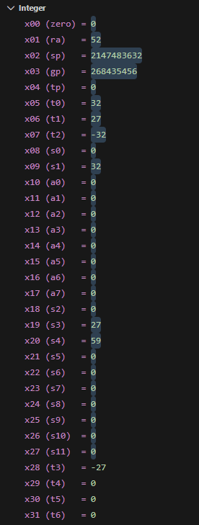

Task 4a
Write the RISC-V assembly code for each item below. Try guessing the result in each destination before executing the instruction and corroborate it after execution:

- Store x10 as unsigned integer at address 0x100.

- Store x11 as unsigned integer at address 0x1F0.

- Load an unsigned short integer (two bytes) from address 0x100 in x12.

- Load a short integer from address 0x1F0 in register x13.

- Load a singed character from address 0x1F0 in register 0x14.

Add screenshots of your results (register & memory both)

Task 4b

Provide appropriately commented codes (Mention question part before each part)

Add screenshots of your results (register & memory both)

Exercise

1. Provide appropriately commented codes (Mention question part before each part)

Add screenshots of your results (register & memory both)

2. Provide appropriately commented codes (Mention question part before each part)

Add screenshots of your results (register & memory both)

Lab 01

Assessment Rubrics

Task No. | LR 2  Code | LR 5  Results | AR 7  Report Submission/Code Comments
Task 1a | /05 | /05 | /20
Task 1b | /10 | /05 | /20
Task 2a | /10 | /05 | /20
Task 2b | /20 | /05 | /20
Exercise | /10 | /05
Total Points |  | /100 Points
CLO Mapped |  | CLO 2

# | Assessment Elements | Level 1: Unsatisfactory | Level 2: Developing | Level 3: Good | Level 4: Exemplary
LR2 | Program/Co de/ Simulation Model/ Network Model | Program/code/simulation model/network model does not implement the required functionality and has several errors. The student is not able to utilize even the basic tools of the software. | Program/code/simulation model/network model has some errors and does not produce completely accurate results. Student has limited command on the basic tools of the software. | Program/code/simulation model/network model gives correct output but not efficiently implemented or implemented by computationally complex routine. | Program/code/simulation  /network model is efficiently implemented and gives correct output. Student has full command on the basic tools of the software.
LR5 | Results & Plots | Figures/ graphs / tables are not developed or are poorly constructed with erroneous results. Titles, captions, units are not mentioned.  Data is presented in an obscure manner. | Figures, graphs and tables are drawn but contain errors. Titles, captions, units are not accurate. Data presentation is not too clear. | All figures, graphs, tables are correctly drawn but contain minor errors or some of the details are missing. | Figures / graphs / tables are correctly drawn and appropriate titles/captions and proper units are mentioned. Data presentation is systematic.
AR9 | Report Content/Code Comments | No summary provided. The number/amount of tasks completed below the level of satisfaction and/or submitted late | Couldn’t provide good summary of in-lab tasks. Some major tasks were completed but not explained well.  Submission on time. Some major plots and figures provided | Good summary of In-lab tasks. All major tasks completed except few minor ones. The work is supported by some decent explanations, Submission on time, All necessary plots, and figures provided | Outstanding Summary of In-Lab tasks. All task completed and explained well, submitted on time, good presentation of plots and figure with proper label, titles and captions

